PRACTISE QUESTIONS – MEASURES OF DISPERSION
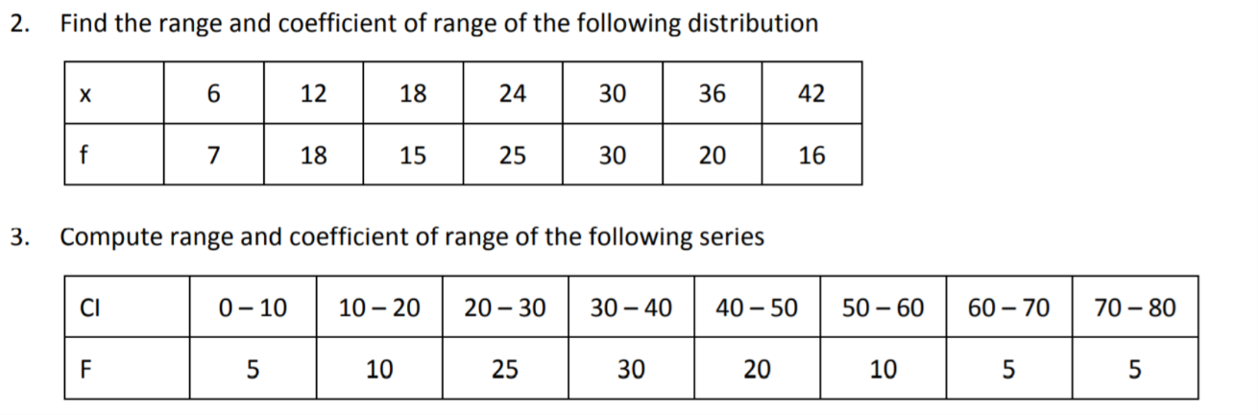
- Find the Quartiles for a Given Data Set
Data Set: [3,7,8,5,12,14,21,13,18]
- Calculate Q1, Q2, and Q3.
Data Set: [22,7,3,45,10,15,17,23,21,29,35,41,32,27,25,13,19,28,30,34]

- Calculate Q1, Q2, and Q3 for the grouped data.
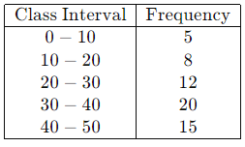
- A teacher asked the students to complete 60 pages of a record notebook. Eight students have completed only 32, 35, 37, 30, 33, 36, 35, and 37 pages. Find the standard deviation of the pages yet to be completed by them.
- Find the variance and standard deviation of the wages of 9 workers given below: ₹310, ₹290, ₹320, ₹280, ₹300, ₹290, ₹320, ₹310, ₹280.
- If the standard deviation of the data is 4.5 and if each value of the data is decreased by 5, then find the new standard deviation.
- If the standard deviation of the data is 3.6 and each value of the data is divided by 3, then find the new variance and new standard deviation.
- For a group of 100 candidates, the mean and standard deviation of their marks were found to be 60 and 15 respectively. Later on, it was found that the scores 45 and 72 were wrongly entered as 40 and 27. Find the correct mean and standard deviation.
- The rainfall recorded in various places in five districts in a week is given below. Find its standard deviation.
- In a study about viral fever, the number of people affected in a town was noted as follows. Find the SD of the data.
- The time taken by 50 students to complete a 100 meter race are given below. Find its standard deviation.
- The mean and variance of seven observations are 8 and 16 respectively. If five of these are 2, 4, 10, 12, and 14, then find the remaining two observations.

